Standard Protocol for
Sodium dodecyl sulfate Polyacrylamide Gel Electrophoresis (SDS-PAGE)

31January2011 Revision
Reagents needed:

10X Electrophoresis Buffer:
30 g Tris
145 g Glycine
10 g SDS
bring to 1 L with H2O

For Polyacrylamide Gel:
1 M Tris-Cl (pH 8.8) (Resolving gel buffer)
1 M Tris-Cl (pH 6.8) (Stacking gel buffer)
20% (w/v) SDS (4C)
40% Acrylamide (37.5:1 acrylamide:bis-acrylamide) (BioRad, 4C)
10% Ammonium persulfate (make fresh daily)
TEMED (room temperature)
0.01% SDS (room temperature)
Note: Check the label on the buffer! Some resolving buffers contain SDS already. If this is the case, replace the SDS aliquots below with H₂O

Coomassie Staining Solution |  | Destaining Solution
0.1% Coomassie brilliant blue R-250 |  | 40% Methanol
40% Methanol |  | 10% Acetic Acid
10% Acetic Acid
Note: Gelcode Blue staining reagent may be available. Deionized water is the destaining reagent if using Gelcode Blue stain.

 | Final Resolving Gel Percentage (vol in mls)
 | 5% | 7% | 9% | 10% | 12% | 15%
Stock Solution
1M Tris pH 8.8 | 3.75 | 3.75 | 3.75 | 3.75 | 3.75 | 3.75
20% SDS | 0.05 | 0.05 | 0.05 | 0.05 | 0.05 | 0.05
40% Acrylamide | 1.25 | 1.73 | 1.69 | 2.50 | 3 | 3.75
H₂O | 4.85 | 4.40 | 3.81 | 3.73 | 3.2 | 1.25
10% Ammonium persulfate | 100 μL | 100 μL | 100 μL | 100 μL | 100 μL | 100 μL
TEMED | 10 μL | 10 μL | 10 μL | 10 μL | 10 μL | 10 μL

Stacking Gel Recipe

 | Vol in mL
Stock Solution
1M Tris pH 6.8 | 0.63
20% SDS | 0.05
40% Acrylamide | 0.83
H₂O | 3.4
10% Ammonium persulfate | 50 μL
TEMED | 5 μL
Experimental Design:

Notes:
- Always think about why you are performing each step. If your only answer is ‘Because the sheet says so’, then stop now and go back over the protocol.
- If something doesn’t look or feel right, it probably isn’t. There’s never any harm in asking for help or advice.
- Set up gel plates before you mix the gel solution.
- Use the backing plates with 0.75mm spacers and choose a comb--number of wells varies.
- Make both resolving gel and stacking gel mixtures (NO APS or TEMED)--then add APS and TEMED to resolving gel, mix and pour about 3-3.5ml per gel (6 cm from the bottom of the gel is a good height).
- After the resolving gel is poured, cover the polymerizing gel solution with 0.1% SDS, butanol or 70% ethanol. This creates a smooth top of the gel and prevents oxygen from interfering with the polymerization reaction.
- Once the resolving gel polymerises, rinse the covering solution (0.1% SDS, butanol or ethanol) from the top of the resolving gel.
- Add APS and TEMED to your stacking gel mixture and pour it gently on top of the resolving gel (using a pasteur pipette works well). Put in the comb and let solidify.
- You can keep gels overnight at 4°C if they are wrapped to prevent drying out and if you keep the comb in. Note: just before you want to load gels, wash out wells with running buffer to remove unpolymerised acrylamide.
- Pour Polyacrylamide Gel
  - Assemble gel sandwich
    - Wash well and rinse plates, spacers, and combs with 70% ethanol
    - Assemble glass plate sandwich.
    - Slide plate assembly into plate clamp assembly and stand vertically. Ensure that the glass plate sandwich is 1 – 2 mm below the edge of the plate clamp by gently sliding the clamp up before sealing the assembly. This prevents the unpolymerised resolving gel solution from leaking out of the sandwich. Place combined assembly into gel casting stand.
  - Pour separating gel (5-15%)
    - For routine protein analysis (10 kDa < x < 100 kDa), pour a 12% resolving gel. Smaller proteins and peptides require higher acrylamide percentages (>15%) and large proteins require lower gel percentages (<10%)
    - Add 100 µl 10% APS and 6 µl TEMED (increase to 10ul TEMED if gel percent is less than 8%)
    - Mix well by inverting tube CAREFULLY. Remember: Oxygen inhibits the polymerization reaction. Bubbles contain oxygen. (See where this is going?)
  - Pour solution into gel sandwich using a Pasteur pippette (run it along a side spacer) until desired level (5.5 – 6.5 cm)
  - Gently overlay with 0.01% SDS, butanol or 70% ethanol.
  - Allow gel to polymerize 30-60 minutes at room temp or until interface appears. If the gels are not to be run on the same day, they can be removed from the clamps, covered with resolving gel buffer, wrapped and stored at 4C for 2 -3 days.
- Pour stacking gel (3.75%)
  - Pour off aqueous layer from separating gel and rinse with ddH2O
  - Combine components for stacking gel
  - Pour stacking solution on top of separating gel
  - Insert comb into stacking gel taking care to avoid forming bubbles on the ends of the teeth
  - Allow gel to polymerize 30-60 minutes or until ready
- Clamp gel onto electrophoresis tank
  - Carefully remove binding clips and the comb from gel
  - Place gel / glass plate sandwich into electrophoresis core. The short glass plate should face the center, or inside of the core. If the plate sandwich does not fit in the core, check the direction of the short glass plate and the rubber gasket at the center of the core to make sure everything is correct. If only one gel is to be run, place the buffer damn on the other side of the core, otherwise, place the second glass plate sandwich on the other side of the core.
  - Place the core assembly into the running tank.
  - Add 1X Electrophoresis buffer to the core. Buffer should be added to the top of the assembly. Add 1 – 2 inches of 1X Electrophoresis buffer to the running tank.
  - Rinse out wells with buffer in preparation for sample loading.
- Prepare samples
  - Thaw protein samples rapidly in room temp water bath
  - Add 1/5 vol 6X Sample Buffer to protein samples
  - Heat samples for 5-10 minutes in the 95C dry bath.
  - (Optional) Spin down samples in microfuge for 5 minutes
- Separate protein samples by PAGE
  - Load samples into wells using 200 µL pipet tip. Take care not to separate glass plates by wedging the tip too far into the well. Normally, 25 µL of sample can be loaded into each well.
  - Fill empty wells with 1X Sample dye
  - Attach electrodes so that proteins will move towards the anode (+ or red lead)
  - Run gel at 100-200 V until dye front reaches the bottom of the gel. Running time will vary based upon percentage cross linking of gel and buffer composition
- Stain gel to visualize protein bands
  - Disconnect electrodes, dump out electrophoresis buffer, and remove gel sandwich from tank
  - Remove side spacers and carefully pry apart the plates so that the gel remains on one plate
  - Pour staining solution into pipet tip box.
  - Invert plate with gel into the staining solution and gently allow gel to "float" off of plate into solution
  - Cover with plastic wrap and gently agitate gel on gel rocker for 15-30 minutes (longer will increase sensitivity but requires a longer destaining period)
  - Remove staining solution (can be reused many times) and rinse gel with ddH2O to remove excess stain. DO NOT PLACE WATER STREAM ONTO GEL ITSELF. Add water to the pipet tip box and let it gently wash over gel surface
  - Add destaining solution and agitate on gel rocker for 10-15 minutes
  - Change destaining solution and agitate until proper level of destaining is achieved (can destain overnight if needed)

Appendix:

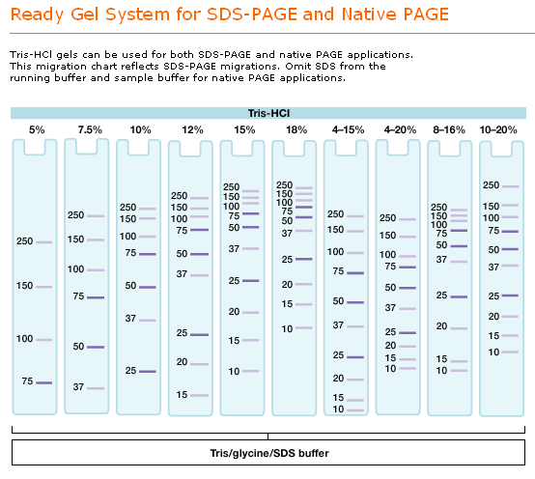
Figure 1: Effect of gel percentage on protein separation

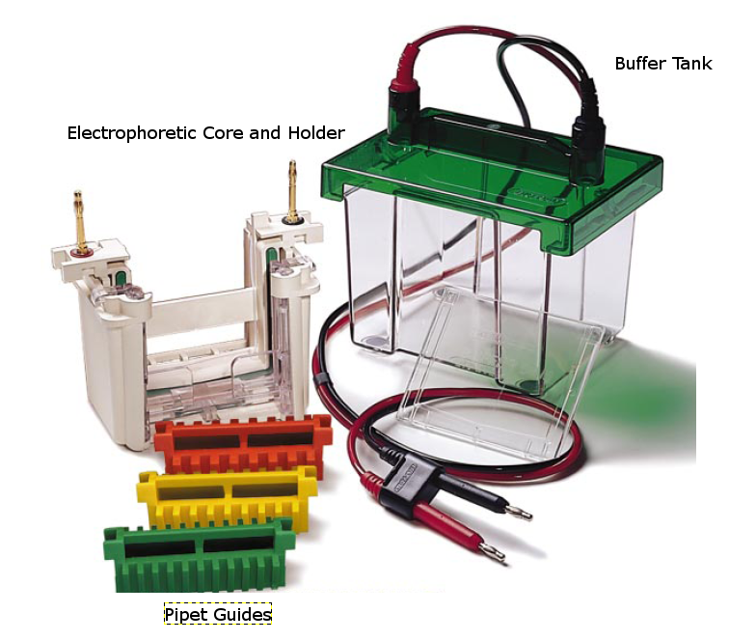
Figure 2: Electrophoretic Tank and Core assemblies

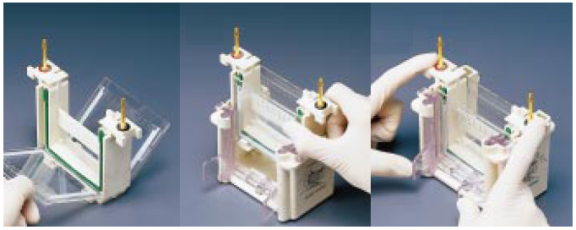
Figure 3: Adding gel sandwiches to the electrophoretic core and placing in holder

